VW scandals could prove another headache for Europe’s refiners
Following VW’s admission of cheating on diesel NOX and particulate emissions in October, November saw a second scandal hit the company, when it acknowledged that carbon dioxide emissions and fuel economy figures were incorrect for 800,000 vehicles. Employees claimed that 2012 emissions goals to reduce vehicle CO₂ emissions by 30 percent by 2015 compared to 2006 levels, were too hard to achieve – opening up further questions over the ability of engine manufacturers to achieve required environmental standards using conventional combustion engines.
Most attention has been focussed on the impact of these VW scandals on the car industry, but there could also be implications for the energy sector. With VW the leading diesel car manufacturer globally, the scandal has already been a knock to the fuel’s demand prospects, with a number of countries reviewing incentives relative to gasoline. But the situation could be far worse than acknowledged. The scandal has shone a light at the testing procedures, and found them sorely wanting.
According to a recent report by Hungary’s MOL, most car manufacturers have a far worse record than VW under normal conditions (see table 1). This suggests testing regimes fail to measure diesel NOX emissions correctly, raising questions over the ability of diesel to meet standards generally.
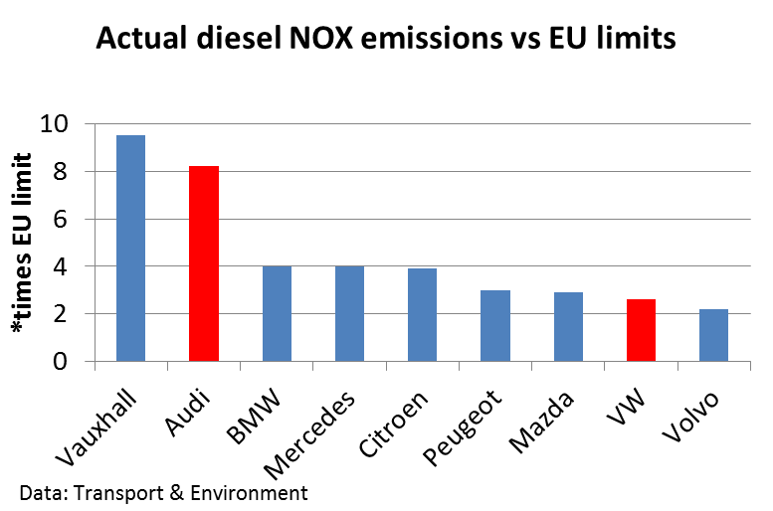
Table 1. Source: MOL
The situation has shone a light on the trade-off between fuel economy, performance and particulate emissions. If MOL is right and tests are improved to realistically reflect NOX emissions, fuel economy and performance may fall for many manufacturers, unless cost rises. Add to this VW’s November CO₂ scandal, and the situation suggests we may be approaching the limits to further improvement in combustion engines generally.
If emissions cannot be reduced by increasing fossil fuel efficiency (if it is at the expense of air quality, or if tests are not reflecting reality), then it is more urgent that alternatives are found to both diesel and gasoline. Several leading car makers have already said they are switching research and investment to electric and hybrid engines in the wake of the scandal - including VW itself - in their efforts to reduce emissions from the transport sector and improve performance.
VW said in early October that it would move investment to electric and hybrid cars in Europe, a move that is partly intended to improve public image, and reverse some of the damage done from the diesel emissions. "We are becoming more efficient, we are giving our product range and our core technologies a new focus, and we are creating room for forward-looking technologies by speeding up the efficiency programme," said VW's Dr Herbert Diess. VW also revealed that its flagship Phaeton model would in the future be purely electric, capable of driving long distances on a single charge.
Regulators and consumers too, may follow suit. In the UK, the Institute of the Motor Industry (IMI) has found 53 percent of drivers planning to buy or lease a car in the next two years are looking at electric or hybrid vehicles as their next car. This compares to the 56,000 electric and hybrid cars sold so far this year, which represented only 3 percent of all new car registrations – illustrating the rapid rise in interest.
Diesel doldrums
For the moment the biggest impact is limited to diesel, with many regulators reviewing its preferable treatment relative to gasoline – put in place in an effort to take advantage of its higher fuel economy to cut CO₂ emissions. Much of the excise and taxation designed to favour diesel in Europe could well be reversed, which – in the short term at least – may encourage the use of gasoline in transportation, as well as natural gas (CNG and LNG), electric and hybrid vehicles. Car buyers too, may not look on diesel as favourably, irrespective of tax changes.
Clamour is already growing for favourable taxes applied to diesel to be removed. In the UK, Stephen Tindale, ex head of Greenpeace and advisor to Tony Blair’s government at the time favourable diesel taxes were introduced, acknowledged in early October that the policy had been flawed, and worse still, was possibly “responsible for many deaths”. The additional mileage possible using diesel engines may have cut the carbon dioxide per mile, but it incurred a whole host of additional pollutants, he added.
Speaking recently on the BBC, ex-BP chief executive, John Browne, said: “This crisis has opened up questions about diesel itself, which will create a very difficult situation for the oil industry… If they have to produce more gasoline they will be able to, but it could create some interesting pricing problems.” He added that a switch to gasoline would take time and would be likely to increase refining costs. “Gasoline prices would certainly be likely to rise relative to diesel,” he said. This could alter refinery economics and undermine the investment that had been made to produce clean European diesel grades.
Good intentions
Europe had been moving towards cleaner emissions using standards applied both to diesel quality and engine performance, with the two progressing in tandem. The purification of diesel fuel to the low sulphur levels required (Euro 5, or 0.01%) has already cost the refining industry billions to install expensive desulphurisation equipment. A fall in European demand could undermine this investment, and require an expensive reconfiguration of capacity to favour a lighter gasoline-focused yield.
Similarly, billions of dollars have been spent on refineries designed to export Euro grade diesel to Europe from the Middle East and elsewhere. In the last year or two, more than 1.2 million b/d of refining capacity has been put into operation in the Middle East, with a further 2.2 million b/d by 2020, according to Enerdata. Most of this will be up to Euro-5 standard, targeting Europe as part of attempts to add value to oil exports. US supply too, had been expected to continue to slip across the Atlantic in greater quantities – pushed out if its home market by increased LNG use and rising unconventional crude production and refining.
The fall out could be significant for Europe’s refining sector, which has already seen multiple closures over recent years as demand has slowly edged down. Before the scandal broke, surging imports and falling demand had already led analysts to forecast the closure of at least ten more European refineries by 2018, on top of the 1.2 million b/d that closed recently. All Europe’s largest refiners, including shell, Total and Eni, have already been looking to sell or adapt plants to lower petroleum product demand, which has declined by more than 18% since 2006, according to Enerdata – although crude price falls have produced a slight recovery in demand this year as drivers responded to lower prices. Fall-out from the VW diesel scandal could accelerate the long term downward trend, leading to the winding up of many refineries more quickly across the continent.
However, as MOL also points out in its report, lower diesel demand would actually benefit Europe by improving its’ refined product imbalance, making it less reliant on imports. The continent currently has to import diesel, while it has a gasoline surplus which is often exported for the US driving season, and to other Atlantic basin countries (see table 2).
Table 2. European motor transport fuels imports and exports, 2013 (mmt/yr)
 | EU gasoline exports | EU diesel imports
North America | 18.6 | 14.7
Russia | - | 18.0
Asia | 6.0 | 5.9
Africa | 11.2 | -
Total | 36.0 | 43.6
Source MOL
MOL also suggests that the impact on diesel demand is likely to be restricted to Europe. With only 7% of global demand, this means the overall impact will probably be limited to the Atlantic Basin and possibly Mideast Gulf markets. The bulk of anticipated diesel demand growth – mostly in Asian heavy transport markets - is unlikely to be affected much, in the short to medium term at least. MOL concludes that if this is the case, other factors such as new marine fuel regulations, or cheaper gas as a result of fracking, will prove far more important for diesel demand than the VW scandal.
However, MOL may be underestimating the impact. Early signs are that regulators may be looking for innovative ways to make VW pay for its emissions cheating. Penalties could, for example, be directed to expanding electric vehicle access - including power points, finance and incentives. Volkswagen is reportedly setting aside billions of dollars for this purpose in the run up to its November 20th deadline to propose a reparations plan to the California Air Resources Board (CARB).

